**IOT Based Obstacle Avoidance Robot –Software Requirements Specification**

**Prepared by,**

Aishwarya.R (1JT13CS002) Anitha.M (1JT13CS008)

Latha.G.R (1JT13CS025) Meghana.R (1JT13CS027)

**SOFTWARE REQUIREMENT SPECIFICATIONS**

**1.1 Software Requirements and Specification**

A document details the software requirements specification for the IOT BASED OBSTACLE AVOIDANCE ROBOT.The project is design to build an obstacle avoidance robotic vehicle using ultrasonic sensors for its movement. A micro-controller (AT mega 8) is used to achieve the desired operation. A robot is a machine that can perform task automatically or with guidance. Robotics is a combination of computational intelligence and physical machines (motors). Computational intelligence involves the programmed instructions. The project proposes robotic vehicle that has an intelligence built in it such that it directs itself whenever an obstacle comes in its path. An ultrasonic sensor is used to detect any obstacle ahead of it and sends a command to the micro-controller. Depending on the input signal received, the micro-controller redirects the robot to move in an alternate direction by actuating the motors which are interfaced to it through a motor driver.

**1.1.1 Hardware Requirements**

The hardware requirements for the project are

* Micro Controller: Arduino UNO R3
* Camera module
* Sound module
* Sensors : Ultrasonic sensor
* Display: Serial Monitor
* Robot chassi (with 2 continuous servo motor)
* Battery holder (9v Battery power)
* Jumper cables
* Mini bread board

**1.1.2 Software Requirements**

* Operating system: Windows 7,8, Arduino 1.6
* Memory: SRAM
* Storage: Flask EEPROM
* CPU: Atmel AVR, ARM Cortex-M, Intel Quark
* Programming Language : C,C++

**1.1.3 User Requirements**

* Android Version : 4.2.2
* Processor : Octa-core Processor
* RAM : 1GB
* Secondary Memory : 32GB

**1.1.4 Functional Requirements**

In a functional requirement defines a function of a software system or its component. A function is described as a set of inputs, the behavior, and outputs. A functional requirement defines a function of a software system or its component. It captures the intended behavior of the system. This behavior may be expressed as services, tasks or functions the system is required to perform.

This section deals with the functional requirements of our project:

* Arduino Board must be connected to the Robotic car.
* Source is given as battery to which all components are connected.

**1.1.5 Non-Functional Requirements**

Non-functional requirement is a requirement that specifies criteria that can be used to judge the operation of a system, rather than specific behavior. They are the metrics that are considered to measure the performance of the developed system.

This section deals with the various non-functional requirements of our project:

* **Reliability**: As a system provide the right tools for discussion, problem solving it is made sure that the system is reliable in its operation and for securing the sensitive details.
* **User friendly:** Device provides an friendly environment as it occupies less space and no need to monitor frequently
* **Privacy and Security:** There are no privacy issues and
* **Usability:** The system is easy to handle and navigates in most expected way.

**1.2 Arduino UNO R3**

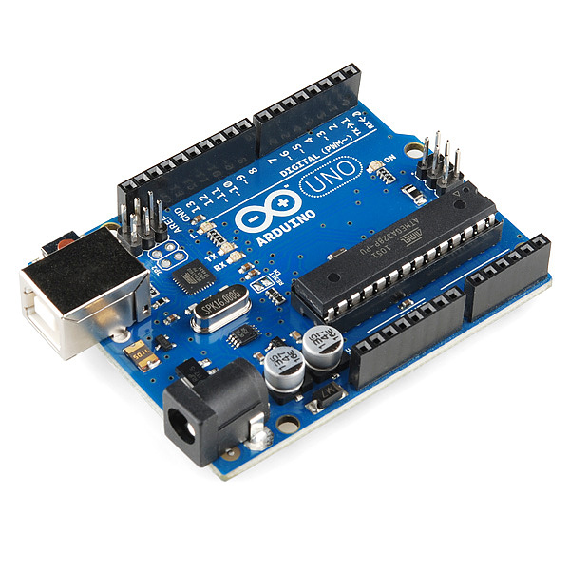

**Figure 1.1:** Arduino UNO R3

This is the new Ardunio R3. In addition to all the features of the previous board, the Uno now uses an ATmega 16U2 instead of the 8U2 found on Uno. This allows for faster transferrates and more memory.

**Features:**

* ATmega328 micro controller
* Input voltage 7-12V
* 14 Digital I/O pins (6 PWM outputs)
* 6 Analog Inputs
* 32k Flash Memory
* SRAM: 2 KB
* Clock speed: 16Mhz
* DC Current per I/O pin: 40 mA
* Operating Voltage :5V
* EEPROM

**1.3 Camera Module**

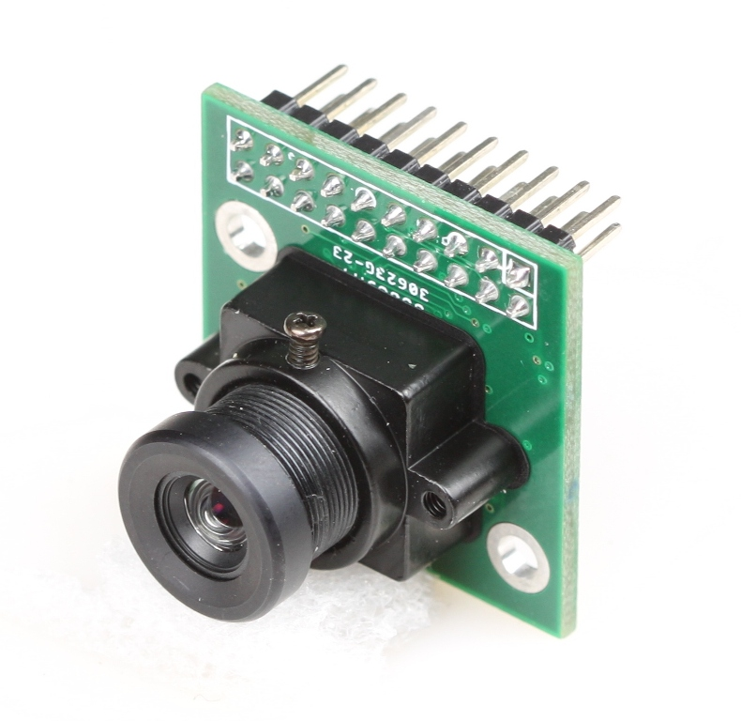

**Figure 3.2:** Camera Module

This camera module can perform image processing such as AWB (auto white balance), AE (automatic exposure) and AGC (automatic gain control), for the video signal coming from CMOS sensor. What’s more, in fusion of other advanced technology such as image enhancement processing under low illumination, and image noise intelligent forecast and suppress this module would output high quality digital video signals by standard CCIR656 interface.

OV7670 built-in JPEG decoder supported reatime encoding for collected image, and external controller can easily read the M – JPEG video streams, achieving the camera design of double stream.

OV7670 supported motion detection and OSD display function of screen characters and pattern overlay, capable of self-defining detection area and sensitivity.

This is an Arduino camera module,  adopted the Surveillance cameras digital image processing chip-OV0706, specially designed for image acquisition and processing application,  based on TTL communication interface, very convenient to connect with Arduino controller, able to read image and data via UART serial port, and then perform some image processing.

**1.4 Ultrasonic Sensor**

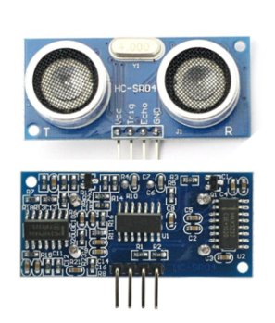

The HC-SR04 ultrasonic sensor uses sonar to determine distance to an object like bats do. It offers excellent non-contact range detection with high accuracy. It comes complete with ultrasonic transmitter and receiver module.

PINS:

VCC: +5VDC

Trig: Trigger (INPUT)

Echo: Echo (OUTPUT)

GND: GND

FEATURES OF ULTRASONIC SENSOR.

* Power Supply :+5V DC
* Quiescent Current : <2mA
* Working Current: 15mA
* Effectual Angle: <15°
* Ranging Distance : 2cm – 400 cm/1″ – 13ft
* Resolution : 0.3 cm
* Measuring Angle: 30 degree
* Trigger Input Pulse width: 10uS
* Dimension: 45mm x 20mm x 15mm